Upon Running:



Which contains:

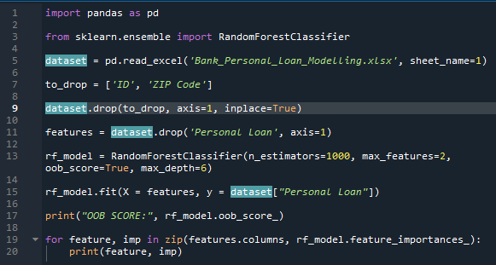

We get output:

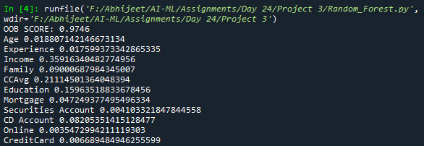

From which we conclude:

Only Income, CCAvg, Education and CD Account have a decent importance

So we use these to build Decision Tree:

We run:



Which contains:

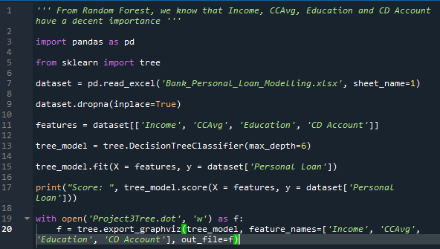

We get output:



And



Upon running this file on webgraphviz.com we get a tree that looks like:

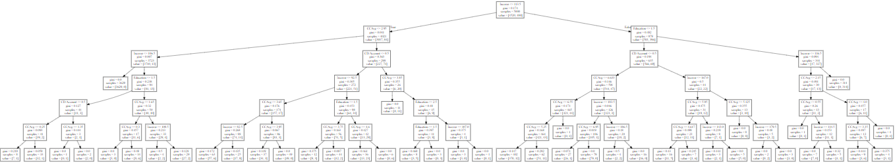

The Rule-Set is:

1. If **CCAvg** is **<= 1.35** , **CDAccount** is **> 0.5** , **Education** is **<= 1.5** , **Income** is **>106.5** and **<=113.5** , Personal Loan was **Approved**
2. If **CCAvg** is **> 1.35** and **<= 2.95** , **CDAccount** is **> 0.5 , Education** is **<= 1.5** , **Income is >106.5** and **<=113.5** , Personal Loan was **Refused**
3. If **CCAvg** is **> 2.95** , **Income** is **<= 106.5** ,Personal Loan was **Refused**
4. If **CCAvg** is **<= 0.3** , **Income** is **> 106.5** and **<= 113.5** ,Personal Loan was **Refused**
5. If **CCAvg** is **> 3.95** and **<= 2.95** , **CDAccount** is **<= 0.5** , **Education** is **> 1.5** , **Income** is **> 113.5** and **<= 92.5** , Personal Loan was **Refused**
6. If **CCAvg** is **<= 3.85** , **CDAccount** is **> 0.5** and **<= 0.5 , Income** is **<= 113.5** , Personal Loan was **Approved**
7. If **CCAvg** is **> 4.6** , **CDAccount** is **<= 0.5 , Education** is **> 1.5** , **Income** is **> 92.5** and **<= 113.5** , Personal Loan was **Approved**
8. If **CCAvg** is **> 3.385** , **Education** is **> 1.5** and **<= 2.5** , **Income** is **> 0.5** , Personal Loan was **Approved**
9. If **CCAvg** is **> 3.85** , **CDAccount** is **> 0.5 , Education** is **> 2.5** , **Income** is **<= 107** , Personal Loan was **Refused**
10. If **CCAvg** is **> 3.85** , **CDAccount** is **> 0.5 , Education** is **> 2.5** , **Income** is **> 107** and **<= 113.5** , Personal Loan was **Approved**
11. If **CCAvg** is **> 6.55** and **<= 6.633** , **CDAccount** is **<= 0.5** , **Education** is **<= 1.5** , **Income** is **> 113.5** , Personal Loan was **Approved**
12. If **CCAvg** is **> 6.95** , **CDAccount** is **<= 0.5** , **Education** is **<= 1.5** , **Income is > 113.5** and **<= 183.5** , Personal Loan was **Refused**
13. If **CCAvg** is **> 6.633** , **CDAccount** is **<= 0.5** , **Education** is **<= 1.5** , **Income is > 186.5** , Personal Loan was **Refused**
14. If **CCAvg** is **<= 5.95** , **CDAccount** is **> 0.5** , **Education** is **<= 1.5** , **Income is > 165.5** , Personal Loan was **Approved**
15. If **CCAvg** is **> 5.95** , **CDAccount** is **> 0.5** , **Education** is **<= 1.5** , **Income is > 143** and **<= 168.5** , Personal Loan was **Refused**
16. If **CCAvg** is **> 5.95** , **CDAccount** is **> 0.5** , **Education** is **<= 1.5** , **Income is > 168.5** and **<= 179.5** , Personal Loan was **Approved**
17. If **CCAvg** is **> 5.95** , **CDAccount** is **> 0.5** , **Education** is **<= 1.5** , **Income is > 179.5** , Personal Loan was **Refused**
18. If **Education** is **> 1.5** , **Income is > 116.5** , Personal Loan was **Approved**
19. If **CCAvg** is **<= 0.55** , **Education** is **> 1.5** , **Income is > 113.5** and **<= 116.5** , Personal Loan was **Approved**
20. If **CCAvg** is **> 0.55** and **<= 1.1** , **Education** is **> 1.5** , **Income is > 113.5** and **<= 116.5** , Personal Loan was **Refused**
21. If **CCAvg** is **> 4** , **Education** is **> 1.5** , **Income is > 113.5** and **<= 116.5** ,PersonalLoan was **Approved**